
FOR IMMEDIATE RELEASE: November 30, 2023
CONTACT: pressoffice@cityhall.nyc.gov, (212) 788-2958

MAYOR ADAMS LAUNCHES NEW EFFORT TO MAKE THOUSANDS OF NYC INTERSECTIONS SAFER, PART OF BROAD NEW STREET SAFETY INITIATIVE

Adams Administration to Make Safety Improvements to at Least 2,000 Intersections per Year, Including Adding Lifesaving Sight Lines to at Least 1,000

NYPD to Include Traffic Violence Data in Regular CompStat Reporting for First Time, Treating Traffic Safety as Core Public Safety Issue

Mayor Adams to Expand Safety Technology Pilot in City Vehicles and Sign Executive Order Requiring Safety Technology in Contractor and Licensee Heavy-Duty Vehicles

NEW YORK – New York City Mayor Eric Adams today launched an aggressive, three-pronged effort to rapidly accelerate the city’s ongoing efforts to make streets safer for all New Yorkers and road users, as traffic fatalities continues to rise nationally, beginning by doubling down on the administration’s focus on improving safety at intersections. Under this initiative, the Adams administration will make safety improvements to intersections at double its current rate — delivering upgrades to at least 2,000 intersections per year, with lifesaving visibility improvements through a tool known as daylighting to at least 1,000 of those intersections each year. To build on that work, the New York City Police Department (NYPD) will add traffic violence to its regular CompStat reporting — treating traffic safety as a critical public safety issue — and the administration will make significant safety upgrades to city vehicles and vehicles of city contractors and licensees to make more vehicles safer across the city.

“Protecting New Yorkers is my most sacred responsibility as mayor, and that holds true for traffic violence just as much as any other form of violence. Our streets must be safe places for all New Yorkers — pedestrians, cyclists, and motorists alike,” said Mayor Adams. “Today, I’m excited to announce that we are doubling our current pace of intersection safety improvements, because that’s where more than half of all traffic injuries and deaths take place. We’re going to include traffic violence in CompStat, to treat traffic violence like the serious crime that it is. And we’re ensuring that the city leads the way towards a safer future, starting with our own fleet.”

“One traffic fatality is one too many. We are committed to using every lever — not only the makeup of the street itself but also how we prepare the city’s fleet for the dynamic environment of New York City streets and even how we monitor the data — to ensure that New Yorkers are safe however they choose to get around,” said Deputy Mayor for Operations Meera Joshi. “Traffic violence is violence, plain and simple. We must keep New Yorkers safe, and with this suite of initiatives, we are one step closer to doing just that.”

“This administration is steadfastly committed to reducing traffic violence and ensuring the safety of every New Yorker on our roadways,” said Deputy Mayor for Public Safety Phillip Banks III. “Our city's heartbeat is in the rhythm of its streets, and prioritizing roadway safety is not just a duty but a shared responsibility. Together, we are driving change by accelerating safety improvements to city streets, enhancing data collection and reporting, and investing in state-of-the-art technology that will ensure compliance with local speed laws.”

“Reckless behavior on New York City roadways puts everyone in serious and immediate peril, and eradicating it remains at the core of the NYPD’s intelligence-driven traffic safety policies,” said NYPD Commissioner Edward A. Caban. “Day in and day out, the men and women of the NYPD strive to keep New Yorkers safe in a variety of ways. By including traffic-specific data in CompStat reporting, our ability to fulfill that mission is greatly enhanced.”

“Intersections are one of the most dangerous areas on our streets, and the plan announced today will make them safer by improving visibility,” said New York City Department of Transportation (DOT) Commissioner Ydanis Rodriguez. “One life lost to traffic violence is one too many, and DOT will use every tool in its toolbox to implement safer street designs, advance critical public education efforts, and collaborate with NYPD on robust traffic enforcement.”

“With the expansion of intelligent speed assistance on city fleet vehicles, we are putting the safety of pedestrians, cyclists, other motorists, and our fleet operators first,” said New York City Department of Citywide Administrative Services Commissioner Dawn M. Pinnock. “By including more vehicles in this pilot and adding school buses, we are redefining fleet safety in our city one mile at a time. As the standard bearers for fleet operations citywide, we are leaning into technological advances and prioritizing driver safety trainings to make our city's fleet not just the greenest, but the safest.”

“Every act of traffic violence touches New Yorkers in ways that are seen and unseen,” said New York City Department of Health and Mental Hygiene Commissioner Dr. Ashwin Vasan. “Lives are lost, and families are devastated. That hurt and trauma ripple through entire networks of friends, classmates, neighbors, and acquaintances. And the tools of public health, prevention, data, policy, and interruption of cycles of traffic violence are key to safer streets and a safer and healthier future for us all.”

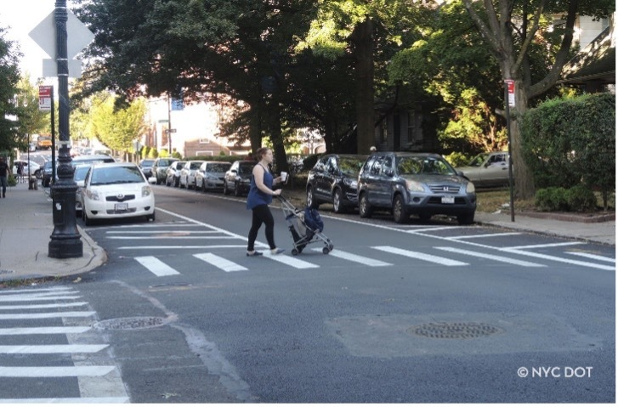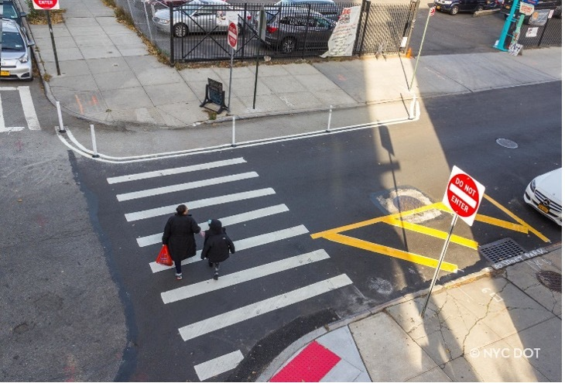

Examples of improved sight lines at intersections after implementation of daylighting treatments. Credit: New York City Department of Transportation

Accelerating Intersection Improvements & Slowing Turns

Intersections pose a special safety challenge in New York City. Crashes at intersections typically comprise 50 percent of all fatalities and 70 percent of all injuries in a year. For pedestrians, the dangers are more pronounced: 55 percent of pedestrian fatalities and 79 percent of pedestrian traffic injuries occur at intersections.

The Adams administration has made intersections a priority for street safety improvements. In January 2022, Mayor Adams announced a plan to make 1,000 intersections safer in one year with design improvements like improved traffic signals, raised crosswalks, and other expanded pedestrian space and visibility measures. The administration exceeded that goal two months ahead of schedule, ultimately completing improvements at 1,400 intersections in 2022.

In 2024, the administration will double that initial goal and make safety improvements at 2,000 intersections with design improvements like raised crosswalks, extended sidewalks, and leading pedestrian signals. Of those intersections, 1,000 will receive daylighting treatments to enhance visibility along with design upgrades to slow down turning vehicles.

This new target represents a dramatic expansion of daylighting — 10 times the requirement under local law and more than three times the current rate. Daylighting is a recommended tool in the National Association of City Transportation Officials’ Urban Design Guide and has contributed to decreases in pedestrian injuries and overall crashes in cities like San Francisco and Hoboken, NJ.

Adding Traffic Violence to CompStat

Through the CompStat 2.0 online dashboard, the NYPD provides New Yorkers with weekly data on the administration’s progress on fighting crime and promoting public safety. Starting January 1, that resource will also include statistics on traffic fatalities, putting traffic violence on par with other violent crime and further elevating efforts to combat traffic violence as a top administration priority.

Additionally, DOT will expand its standard traffic fatality data updated daily and provided regularly to members of the press. Beginning in January 2024, the data will better account for the diverse ways that New Yorkers get around now — delineating traffic fatalities by 11 subcategories, up from the current five. The new table will break down data into the following subcategories: pedestrian, traditional bike, motorcycle, e-bike, moped, stand-up e-scooter, dirt bike/ATV, other motorized two-wheeled device, car, SUV, and other motor vehicle.

Making the City’s Fleet Even Safer

In August 2022, Mayor Adams and DCAS Commissioner Pinnock launched a pilot program to add active intelligent speed assistance (ISA) technology in 50 city vehicles, restricting maximum speeds and ensuring almost universal compliance with speed limits across 750,000 miles traveled. Paired with additional technological improvements, the implementation of this tool has led to a 20 percent decrease in crashes involving city vehicles.

The administration is now expanding that pilot program fivefold and including 50 school buses for the first time — helping keep young New Yorkers safe as they travel to and from school. The city is also applying for a federal grant to add ISA technology to thousands of additional city fleet vehicles.

DCAS will test additional safety improvements to the school bus fleet, including audible turn alerts, safety surround cameras, pedestrian collision warning systems, and back-up sensors. The agency will require that school bus operators participate in urban safety and defensive driver training, with the goal of having all drivers complete that training by the start of the 2025-2026 school year. In the coming weeks, DCAS will release a holistic Safe Fleet Transition Plan, encompassing these and other initiatives to make the city’s school buses safer.

In the coming weeks, Mayor Adams will issue an executive order setting forth a framework for contractor heavy duty vehicles to include vehicle safety training and technology, ranging from truck surround cameras to telematics. Separately, the mayor’s office will work with the Business Integrity Commission to further strengthen rules related to heavy-duty trade waste vehicles.

“As a staunch advocate for public safety and urban wellbeing, I wholeheartedly support Mayor Eric Adams' comprehensive street safety initiative,” said New York State Assemblymember Jenifer Rajkumar. “This bold move to enhance 2,000 intersections annually, particularly with the integration of lifesaving daylighting technology, represents a significant step forward in our collective endeavor to safeguard New Yorkers. Incorporating traffic violence data into NYPD's CompStat reporting is a groundbreaking approach that redefines traffic violence as a fundamental public safety issue. Moreover, expanding safety technology in city vehicles further amplifies our commitment to a safer, more resilient New York. Together, these efforts set a commendable standard for cities worldwide.”

“I commend the administration for its commitment to improve street safety through a variety of traffic calming measures, especially daylighting intersections which increases visibility and makes streets safer for pedestrians and drivers,” said New York City Councilmember Carlina Rivera. “Beyond New Yorkers deserving walkable and bikeable communities, continued traffic injuries and fatalities demonstrate the need to dramatically speed up street redesigns and use all of the tools at our disposal to continue to bring safer streets to New York City.”

“Today’s announcement will save lives,” said Fabiola Mendieta-Cuapio, member, Families for Safe Streets. “We know that the single best way to prevent traffic deaths is through design and policy changes, and we’re grateful that the Adams administration will be implementing proven solutions like daylighting and safety technology. No family should ever have to experience losing someone due to traffic violence, and we know that better street and intersection design will protect New Yorkers across the city.”

“Traffic violence is a public health crisis that demands the full attention of our leaders. Today’s commitment from Mayor Adams to redesign intersections, require safety upgrades to city and contractor vehicles, and more effectively use crash data will save lives.” said Danny Harris, executive director, Transportation Alternatives. “We look forward to working with our partners in City Hall to advance safe streets in every neighborhood so that one needs to fear death or injury on our roads.”

“Few things can improve street safety like creating better visibility at intersections, which Hoboken has proved over the past several years, so we applaud Mayor Adams and DOT for launching this effort to daylight many more New York City intersections,” said Eric McClure, executive director, StreetsPAC. “We also hope that the inclusion of traffic violence data in CompStat reporting will lead to more effective, and equitable, enforcement against dangerous driving. And we’re excited for the city’s commitment to expanding fleet safety initiatives while including contractors and licensees in those efforts.”

“New York City is leading the way on implementing proven vehicle safety technology that will save lives and prevent injuries on our nation’s roads,” said National Transportation Safety Board Chair Jennifer Homendy. “The U.S. is facing a growing public health crisis on our roads, with nearly 43,000 people dying annually and millions more injured. Speed is one of the greatest risk factors in crashes. I applaud the mayor’s actions and strongly encourage other cities, states, and the federal government to follow in the city’s footsteps and take action now to save lives.”

###

