
THE CITY OF NEW YORK
OFFICE OF THE MAYOR
NEW YORK, NY 10007

FOR IMMEDIATE RELEASE: October 23, 2019
CONTACT: pressoffice@cityhall.nyc.gov, (212) 788-2958

VISION ZERO: DE BLASIO ADMINISTRATION INAUGURATES 100TH MILE OF PROTECTED BIKE LANES SINCE 2014 AS PART OF MAJOR NEW “GREEN WAVE” BIKE SAFETY PROJECTS IN BROOKLYN

DOT has installed the de Blasio Administration’s 100th mile of protected bike lanes along Fountain Avenue in East New York; In Boerum Hill, new “green wave” signal timing system changes traffic lights at the speed of bikes

NEW YORK—Mayor Bill de Blasio and DOT Commissioner Polly Trottenberg today announced major new projects as part of the administration’s “green wave” bicycle plan, including the 100th mile of protected bike lanes constructed during the de Blasio Administration and an expansion of “green wave” signal timing to major bike corridors in Brooklyn.

“Vision Zero means making sure people on bikes in every neighborhood feel safe—whether they’re in Boerum Hill, Bath Beach or Bushwick,” said Mayor Bill de Blasio. “We’ve installed 100 miles of protected bike lanes—more than any administration in history—and are not stopping there. With our ‘green wave’ plan, we’re doubling down on our commitment to end senseless traffic fatalities.”

“Through Vision Zero and the ‘green wave,’ this Administration has implemented and created key safety solutions - like the signal timing project in Boerum Hill - and outlined a blueprint for a citywide bike network,” said Deputy Mayor Laura Anglin. “And while we celebrate today’s historic milestone, we are mindful of the remaining challenges we face to ensure anyone who rides a bicycle in New York City feels safe and won’t have their ride end in tragedy.”

“We are proud to come to East New York to celebrate 100 miles of protected bike lanes, with the completion of DOT’s first protected lane project within one of the Bicycle Priority Districts we targeted,” said DOT Commissioner Polly Trottenberg. “As we celebrate this milestone, we are also mindful of our awesome responsibility to continue efforts to build out and strengthen Brooklyn’s bike network as part of Mayor de Blasio’s ‘green wave’ plan. And in a year when two thirds of cycling fatalities have unfortunately been here in Brooklyn, we are excited to embark on innovative new safety projects like the ‘green wave’ downtown.”

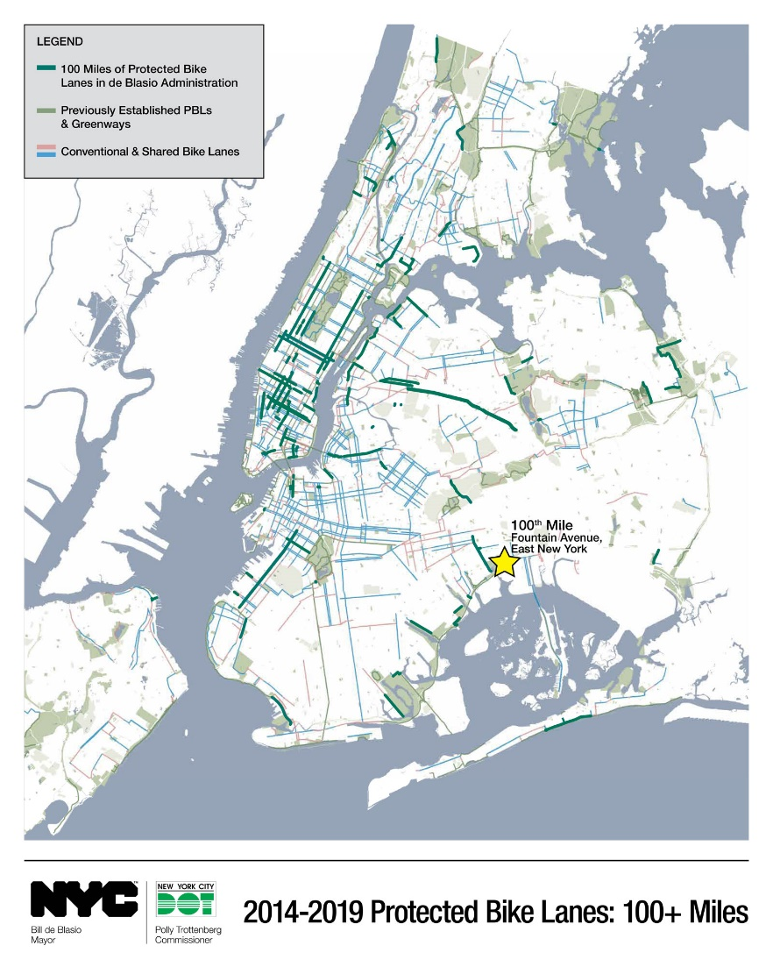

At a press conference in East New York, New York City Department of Transportation officials (DOT) cut the ribbon on the 100th mile of protected bike lanes constructed under the de Blasio Administration along Fountain Avenue. Officials also announced a new lowered speed limit along Linden Boulevard, a Vision Zero priority corridor that has seen 14 fatalities since 2013. DOT also announced that after the successful pilot of “green wave” signal timing in the Boerum Hill neighborhood, the treatment would be expanded to other popular bike routes. More information can be found in today’s New York Times report.

DOT also today named the major protected bike lane projects it plans for this year in Brooklyn, the borough with the majority of fatal cyclist crashes so far in 2019 (16 of 25 total).

Further details about today’s announcement can be found below, or in today’s New York Times report:

Fountain Avenue – Two of 100 Miles of Protected Bike Lanes: The new bike lanes unveiled on Fountain Avenue between Pitkin and Seaview Avenues mark the 100th mile of protected bike lanes constructed during the de Blasio Administration; there are now 126 miles of on-street protected lanes in New York City overall. The new protected lanes bisect East New York, stretching from near the A train station at Euclid Avenue to the new entrance to the Jamaica Bay Greenway and Shirley Chisholm State Park. The Fountain Avenue protected lanes are within Brooklyn Community Board 5, which is among ten Bicycle Priority Districts citywide targeted by DOT; these districts have a limited amount of cycling infrastructure while seeing a disproportionate number of cyclists killed or seriously injured.

Linden Boulevard Lowered Speed Limit: The new Fountain Avenue protected lanes intersect Linden Boulevard, a major east-west priority corridor where DOT in July lowered the speed limit from 30 to 25 MPH as a Vision Zero measure to prevent fatalities and injuries. Since 2013, Linden Boulevard has seen 14 traffic fatalities, including 9 pedestrians and one cyclist.

More Protected Bike Lanes Coming to Brooklyn: DOT announced that under the “green wave” plan, it would complete other major protected lane projects by the end of 2019 elsewhere in Brooklyn:
• 4th Avenue (between 15th and 60th Streets), South Slope/Sunset Park
• Shore Parkway (between Bay Parkway and Bay 53rd Street), Bath Beach
• 7th Avenue (between 65th and 84th Streets), Bay Ridge

“Green Wave” Signal Timing -- DOT also announced that two downtown Brooklyn streets had received the first of new “green wave” bike safety treatments. Last December, DOT retimed the traffic lights along Hoyt and Bond Streets in Boerum Hill between Schermerhorn and Baltic Streets. Streets that serve as major bike routes for cyclists commuting to and from the Brooklyn and Manhattan Bridges, two half-mile sections of Hoyt and Bond had traffic lights synchronized to turn green at the typical cyclist speed of 15 MPH. This allowed cyclists to comfortably ride without stopping, creating a quicker, safer, and less stressful route. Prior to the green wave, the lights on these streets were timed to change at the maximum legal car speed (25 MPH).

The pilot has seen several positive results: bike volumes along the streets, among the busiest of Brooklyn’s bicycle lanes (with over 500 cyclists per hour during rush hours, usually outnumbering cars) saw increases in 2019; vehicle speeds slowed slightly (Hoyt Street) or remained the same (Bond Street), yet traffic volume remained constant --not moving to adjacent streets; and the treatment increased cyclist compliance with traffic-light laws.

With positive results in the pilot’s two corridors, DOT announced that it would undertake “green wave” treatments along three popular bicycle corridors in the next year:

Brooklyn: Clinton Street; Carroll Gardens/Cobble Hill/Brooklyn Heights
Queens: 43rd Avenue, Sunnyside
Manhattan: Prince Street, SoHo

“Bicycling is a great way to stay healthy while getting around and protected lanes are a critical safety feature,” said Health Commissioner Dr. Oxiris Barbot. “Congratulations to everyone in the de Blasio Administration who helped make 100 miles of protected bike lanes available to New Yorkers."

“Thank you Mayor de Blasio and DOT Commissioner Polly Trottenberg for investing in the health and safety of NYCHA residents,” said Gregory Russ, Chair of the New York City Housing Authority. “A new protected bike lane that connects East New York developments to Shirley Chisholm State Park is a major boost to the quality of life for thousands of our NYCHA residents.”

“2019 has been a particularly tragic year on Brooklyn’s roadways, and we have a collective responsibility to make the necessary changes both personally and societally that help ensure our streets will be safer for all who use them,” said Brooklyn Borough President Eric L. Adams. “Safe street infrastructure, including protected bicycle lanes, must exist in all communities and a protected lane on Fountain Avenue and a lower speed limit on Linden Boulevard — a particularly deadly thoroughfare in our borough — are good steps which speak to the need for greater attention to street safety that we have demanded come to central and eastern Brooklyn. Implementing protected bike lanes along 4th Avenue, 7th Avenue, Flatbush Avenue, and Shore Parkway create meaningful north-south connections for a truly boroughwide safe cycling network and extend the cycling network into historically underserved communities. Improving the timing of signals along Bond, Clinton, and Hoyt streets will hopefully improve a safe traffic flow for bike commuters heading to and from Manhattan. These projects are important steps toward Vision Zero, but we cannot rest until every New Yorker feels safe on our streets.”

"2019 has been a particularly tragic year on Brooklyn’s roadways, and we have a collective responsibility to make the necessary changes both personally and societally that help ensure our streets will be safer for all who use them,” said Brooklyn Borough President Eric Adams. “Safe street infrastructure, including protected bicycle lanes, must exist in all communities and a protected lane on Fountain Avenue and a lower speed limit on Linden Boulevard — a particularly deadly thoroughfare in our borough — are good steps which speak to the need for greater attention to street safety that we have demanded come to central and eastern Brooklyn. Implementing protected bike lanes along 4th Avenue, 7th Avenue, Flatbush Avenue, and Shore Parkway create meaningful north-south connections for a truly boroughwide safe cycling network and extend the cycling network into historically underserved communities. Improving the timing of signals along Bond, Clinton, and Hoyt streets will hopefully improve a safe traffic flow for bike commuters heading to and from Manhattan. These projects are important steps toward Vision Zero, but we cannot rest until every New Yorker feels safe on our streets “It is a good day to know that this is the 100th mile of protected bike lane constructed under this administration. New York City needs to be the most pedestrian and cyclists friendly in the Nation,” said Council Member Ydanis Rodriguez, Chair of the Transportation Committee. “The City has seen an increase in bike ridership, with this increase our goal must be to construct 100 miles of protected bikes lanes each year. Along with the expansion of protected bike lanes, we must also ensure that they are accessible to all New Yorkers living in underserved communities. I will continue working with my colleagues, Speaker Johnson, Mayor De Blasio, DOT Commissioner Trottenberg and advocates to ensure we make New York City roads safe for all pedestrians and cyclists”

“Congratulations to the city for this new protected bike lane, which will help even more New Yorkers reach Shirley Chisholm State Park safely and sustainably,” said State Parks Commissioner Erik Kulleseid. “By early October, nearly 100,000 people had already visited this park on Jamaica Bay since its July opening. This bike lane will certainly add to that in the coming years, as more people discover Shirley Chisholm State Park has some 10 miles of great trails for biking and hiking.”

"The best way to improve safety for New Yorkers who bike is to create dedicated space on our streets for traveling on two wheels. Transportation Alternatives thanks Mayor de Blasio and the Department of Transportation for improving safe biking connections throughout the five boroughs, and especially in East New York, which has few safe bike routes," said Dulcie Canton, Transportation Alternatives Brooklyn Organizer. "This is a significant milestone, and we're eager to work with communities and City leaders to win the next 100 miles of protected bike lanes."

“Zero is a large number and using policy to achieve it in the most densely populated city in the United States is more than bold,” said Angela Azzolino, Executive Director of Get Women Cycling. “We want to, we need to reach our goal of zero. Zero fatalities due to car crashes. Imagine that feeling inside us on the day we can say New York City has zero fatalities due to car crashes. Today we commend Mayor de Blasio and his administration on continuing to improve our streets by changing the way we use space. One hundred miles of protected bicycle lanes provide safe alternative methods to everyday travel for people who choose to ride a bike because of its physical separation between a bicycle lane and moving automobile traffic. Protected bicycle lanes also provide safety to those who choose to walk or ride in cars because it calms down traffic, lowering speed. This is a big win for every New Yorker since we know slower car speeds greatly reduce the likelihood of death or serious injury if one or more of us is struck by an automobile.

“I can attest that some of East Brooklyn’s most enthusiastic cyclists ride their bikes one to two times year in their own neighborhoods when they can find safety in numbers in the form of the few bike tours, like Bike East, that traverse area,” said Courtney Williams, Chief Strategist, Brown Bike Girl Bicycle Advocacy Consulting. “The “green wave’s” prioritization of protected bike lane installation across even the neighborhoods that have been historically overlooked by both government resources planners and bike activism is going to liberate many people to cycle more and differently. I am hopeful to see to more people cycling and leading more robust cycling lives as a result of these new mobility options that “green wave” protected bike lanes represent when paired with auto traffic enforcement."

“The unprecedented expansion of protected bike lanes in Brooklyn in 2019 is great news for Brooklyn riders and the NYC bike network," said Bike New York President and CEO Ken Podziba. "The new projects point the way toward a wide-ranging protected bike lane network that reaches every corner of the borough.”

About Vision Zero: In 2014, New York City became the first City in the United States to implement Vision Zero. Through a combination of enforcement, education and engineering, New York City made dramatic changes that have helped drive down fatalities for five consecutive years, bucking national trends. To maintain progress, since the beginning of 2019, New York City has released a Vision Zero Year 5 Report, as well as a major update to its Pedestrian Safety Action Plans, and Green Wave: A Plan for Cycling in New York City.

For more information about the de Blasio Administration’s Vision Zero initiative, please see www.nyc.gov/visionzero.
###

