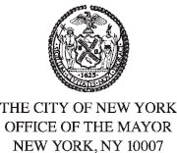
FOR PLANNING PURPOSES
CONTACT: pressoffice@cityhall.nyc.gov, (212) 788-2958

UPDATED PUBLIC SCHEDULE FOR MAYOR ERIC ADAMS
FOR THURSDAY, JANUARY 16, 2025

***Updated Schedule***

On Thursday, New York City Mayor Eric Adams will attend The Real Estate Board of New York’s (REBNY) Annual event. This event is open press.

Press Schedule

Approximately 5:45 PM – Attends REBNY Annual Event
The GlassHouse
660 12th Avenue, 6th floor
New York, NY 10019
Official photos will be available following the event.

###

