
THE CITY OF NEW YORK
OFFICE OF THE MAYOR
NEW YORK, NY 10007

FOR IMMEDIATE RELEASE: October 6, 2017
CONTACT: pressoffice@cityhall.nyc.gov, (212) 788-2958

WITH STREET REPAVING IN HIGH GEAR, MAYOR DE BLASIO ANNOUNCES FIFTY PERCENT DECLINE IN POTHOLES SINCE 2014

DOT names some of the major streets to be paved this fiscal year across all five boroughs; since 2014, DOT has repaved more than 4,500 lane-miles, nearly 1/4th of City streets, an unprecedented pace

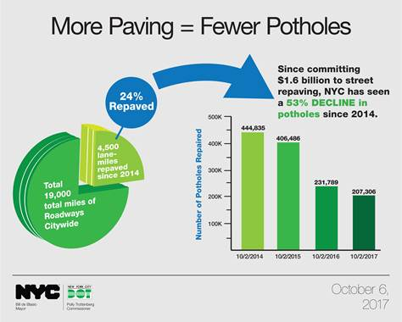

NEW YORK—Mayor Bill de Blasio today announced that thanks to a ten-year investment of $1.6 billion in street repaving, the number of potholes in New York City has declined by over fifty percent - 207,306 so far this year compared to 444,835 as of this date in 2014, a reduction of more than fifty percent. Since 2014, DOT has paved 4,500 lane-miles of roadways out of 19,000 total Citywide, or nearly 25 percent. The Mayor made the announcement while visiting a DOT paving crew along Valentine Avenue in the Tremont section of the Bronx.

“When we took office in 2014, a drive down many City streets could be a bone-rattling experience,” said Mayor de Blasio. “Thanks to the hard work of DOT crews, rides are smoother everywhere, on major roads like the FDR Drive to smaller residential streets in neighborhoods around the City. But the turnaround is not complete; while freshly paved streets mean many fewer potholes, we still have too many, so crews will be both quickly filling potholes and keeping up the pace of repaving in the months ahead.”

“Thanks to Mayor de Blasio’s unprecedented investment in paving, the quality of City roads is up and the number of pothole complaints is down,” said DOT Commissioner Polly Trottenberg. “This fall, our crews will continue to work – literally day and night -- to provide even smoother rides. We ask that if drivers encounter a paving crew, they please give them the necessary space and maintain a safe speed as we try to pave as many streets as possible before winter weather sets in.”

As part of its efforts to maintain work-zone safety, including for Roadways crews repaving and filling potholes, DOT will in the next week be introducing a new Vision Zero “Work Zone Heroes” public-service advertising campaign. The ad encourages safe driving around work zones and features actual DOT employees in the Roadways, Traffic Operations, Bridges and Sidewalk Inspection Management (SIM) divisions.

DOT named some of the major streets planned for repaving for the current fiscal year, which ends June 30th, 2018.

Queens:
• Union St, Northern Blvd to 31 Rd
• Roosevelt Ave., 57 to 61 Streets
• Roosevelt Ave, 69 to 73 Streets
• N/B Van Wyck Service Road, 138 St to Liberty Ave

Brooklyn:
- Colonial Rd, Bay Ridge Pkwy to 85 St
- 5th Ave, Flatbush Ave to Prospect Ave

Staten Island:
- Goethals Road, Richmond Ave to Western Ave.
- Narrows Road, Fingerboard Rd to Britton Ave.
- West Shore Expressway Service Road west, Arden Ave/ Muldoon Ave Exit to Bloomingdale Road

Manhattan:
- W. 96th St., Central Park West to Riverside Dr.
- West End Ave., W. 72nd St. to W. 59th St.
- Central Park -- West and East Drives in the upper 90’s and 100’s

Bronx:
- E. Gun Hill Rd, Webster Ave to Wayne Ave
- Broadway, Mosholu Ave to W 262 Street
- East Kingsbridge Rd, Jerome Ave to East Fordham Rd

DOT also provided the latest number of potholes repaired under the de Blasio Administration:

Calendar Year To Date: |  | 10/2/2014 |  | 10/2/2015 | 10/2/2016 |  | 10/2/2017
Bronx |  | 74,349 |  | 65,594 | 42,492 |  | 46,916
Brooklyn |  | 112,340 |  | 92,506 | 46,747 |  | 43,627
Manhattan |  | 81,565 |  | 65,599 | 36,859 |  | 26,355
Queens |  | 117,312 |  | 127,798 | 79,012 |  | 62,451
Staten Island |  | 59,269 |  | 54,989 | 26,679 |  | 27,957
Total |  | 444,835 |  | 406,486 | 231,789 |  | 207,306

Borough | Number of Potholes Repaired as of 10/2/2017
Bronx | 260,889
Brooklyn | 325,646
Manhattan | 234,987
Queens | 430,101
Staten Island | 188,837
Total | 1,440,460
Staten Island Borough President Jimmy Oddo said, “This Mayor deserves praise for forgoing the inconsequential, ‘We’ve filled the one millionth pothole this Spring’ pomp and circumstance of the past, and for getting to the heart of the matter of New York City’s street conditions. The best way to deliver smooth, drivable roads to New Yorkers is by milling and resurfacing, and in the last four years we have done an epic amount of repaving. ‘Pave, Baby Pave’ is the cure for potholes and the path to smoother, safer streets, and although we are not out of the hole that was built over the previous decade and half, there is an appreciable difference on our streets.”
“It’s not glamorous, but keeping our infrastructure in good shape is an essential task of city government and too often it falls by the wayside,” said Manhattan Borough President Gale A. Brewer. “Whether it’s refurbishing and renewing our parks or repaving and repairing our roads, this work isn’t optional – it’s essential. I thank the de Blasio administration for making this smart investment in road resurfacing and pothole repair.”
“In only three years, Mayor de Blasio has significantly reduced the number of potholes throughout New York City because he has made this issue a priority. This progress is important, because all New Yorkers want a safer and more efficient daily commute. Thanks to these efforts NYC’s avenues and streets –including many in the Bronx --are safer and commuters can get to their destination faster,” said Representative José E. Serrano.

“I’m encouraged by the investments made by the City to improve our roads,” said Representative Joe Crowley. “Potholes are more than a just a nuisance, they pose serious safety risks to drivers, passengers, and pedestrians. I’m glad to see the Department of Transportation aggressively repaving our streets and I thank them for making this a top priority.”

“I commend Mayor de Blasio and the hard-working Department of Transportation crews who work to ensure New Yorkers can now traverse our roads smoothly and safely,” said Representative Adriano Espaillat. “Mayor de Blasio’s commitment to a ground up approach to repair potholes in each of the five boroughs ensures New Yorkers can travel from neighborhood to neighborhood on reliable, fully functional roads. Today’s announcement maintains our city’s road network and is an investment today that benefits the future mobility of New York City.”

"I want to thank Mayor de Blasio and Commissioner Trottenberg for continuing to work to improve the roads and streets across our City," said State Senator Gustavo Rivera. "By investing in their repaving, our City's administration is enhancing the driving experience of New Yorkers, by providing them safe and upgraded roads."

"There is no replacement for sustained infrastructure spending in ensuring the good working order of our roads,” said Senator Marisol Alcántara. “Far too many elected officials kick the can down the road when it’s time to invest in our state's infrastructure, and I am pleased and excited that the de Blasio administration has made fixing potholes a priority. Everyday tasks like this show people that their government is working for them, not for special interests, and I look forward to continuing to work with the administration to improve our infrastructure."

“I applaud Mayor de Blasio for dealing with a problem that has been allowed to fester for too long,” said Assembly Member Jeffrey Dinowitz. “In the past two years we have already seen significant increase in the amount of paving in my district and I look forward to the city’s continued commitment to repaving and repairing our streets.”

Assemblyman Michael Cusick said, “Great to see the city investing in repaving Staten Island roads. Potholes are a major issue on Staten Island and I am glad the city is making an effort to address this ongoing problem. During this past summer, DOT was out in force paving major roadways in our borough. I look forward to working with the city to advocate for better roadways on Staten Island.”

“I applaud the Mayor for his investment in street paving across New York City. Potholes on city streets are a threat to driver safety and burdens drivers with vehicle repair costs,” said Council Member Ritchie Torres. “This investment has been spread across the City in a variety of neighborhoods, today we see street repaving making travel easier in the Central Bronx.”

“Potholes are a huge quality of life issue,” said Council Member Andrew Cohen. “I applaud the administration for their work in fixing our streets. Thanks to the work of the Department of Transportation, our neighborhoods and roadways have safer and freshly paved streets.”

“Thanks to an unprecedented investment in street resurfacing over the past three years, our roads are noticeably smoother, safer and more aesthetically pleasing,” said Council Member Debi Rose. “This sharp decline in the number of potholes is welcome news, and we can drive this number lower with continued investment. This fall, DOT will continue to repave dozens of new roads in my district, and I encourage anyone who commutes on rough roads to call 311 and report them to my office so that we continue to make safer streets for all.”
“Investing in our infrastructure is critical to the safety and quality of life of New Yorkers,” said Council Member Joseph Borelli. “The decrease in potholes on Staten Island not only mitigates damage to cars, but also reduces traffic by making our streets easier to drive on. I know that my constituents appreciate that the city is being proactive by not just patching potholes, but preventing them by fully paving streets as well.”

"On behalf of all the residents of the Upper West Side, I want to recognize the City's enormous effort to repave our streets and drastically reduce the number of potholes,” said Council Member Helen Rosenthal. “In our community this includes W. 96th Street, West End Avenue, and the West and East Drives in Central Park. Street repaving not only creates smoother rides for all of us, it also enhances traffic safety because cars are not weaving to avoid potholes. This is government at work, and we greatly appreciate the effort of all the DOT employees who are making it possible."

“I am happy to hear that the length of roadway on Colonial Road from Bay Ridge Parkway to 85th Street, which has been a hazard for some time, will finally be addressed and repaved in this current fiscal year (ending June 2018). I applaud the Mayor for his efforts in fixing our city’s crumbling infrastructure. The city has lowered the amount of potholes by 50% since 2014, and I look forward to seeing DOT crews continuing to fill the gaps and keep up with the current pace set by the Mayor,” said Council Member Vincent J. Gentile.

“I want to thank everyone involved for the significant improvements made to our communities. The safety and well-being of our neighborhoods starts with a healthy infrastructure. It is essential that our roads are monitored and repaired so cyclists, drivers, and pedestrians have solid ground for passage. I would like to especially commend the hard working DOT crews that keep our city thriving and moving,” said Council Member Laurie Cumbo.

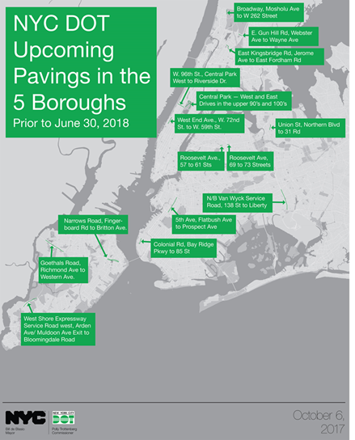
In 2015, the Mayor announced a $1.6 billion commitment to resurface roads all over the city over ten years. DOT repaved 1,265 lane miles in FY16, and 1,324 lane miles in FY17. So far in FY18, crews have resurfaced over 500 lane-miles. It is the highest three-year output of paved lane-miles in DOT’s recorded history.
DOT both procures and produces asphalt at its two plants for resurfacing and filling potholes. In 2017, DOT used nearly 1.3 million tons of asphalt. During pothole season, which generally begins with the onset of cold weather in December, anywhere from 25 to 75 separate DOT pothole crews are dispatched daily. The crews work in all five boroughs, responding to requests from residents and local stakeholders. The average response time to repair a pothole is now less than two days. For information about DOT’s ongoing work to address potholes and maintain the City’s road network, please visit www.nyc.gov/dot .
Pothole conditions should be reported immediately to The Daily Pothole or to 311.
# # #

