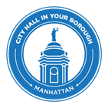
THE CITY OF NEW YORK
OFFICE OF THE MAYOR

FOR IMMEDIATE RELEASE
CONTACT: pressoffice@cityhall.nyc.gov, (212) 788-2958

MAYOR DE BLASIO ANNOUNCES FINAL DESIGN OF PROJECT TO FILL EAST SIDE GREENWAY GAP WILL COMMENCE NEXT WEEK

$100 million initiative comes as part of administration-wide push to complete a contiguous 32-mile waterfront pedestrian promenade and bikeway around Manhattan

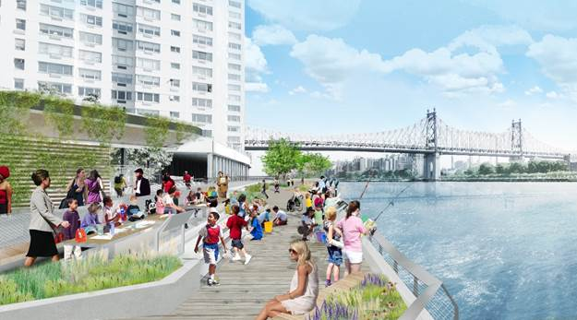

NEW YORK—As part of City Hall in your Borough week in Manhattan, Mayor Bill de Blasio today announced that the formal design process for a new section of the Manhattan Waterfront Greenway between East 61st Street and East 53rd Street will officially kick off next week. The Mayor was joined by local officials to tour a portion of the existing greenway and discussing plans for its expansion. Construction of the new segment will commence in 2019, with completion expected in 2022.

“The Manhattan Greenway stands out as open space that connects communities to one another and also to New York’s expansive and beautiful waterfront. Closing this gap will vastly improve quality of life for New Yorkers, and for East Siders who’ve advocated for decades to get this done,” said Mayor Bill de Blasio.

For more renderings of the project, click here.

“For years East Side residents have looked at the Hudson River Park and wondered why they didn’t have that same type of world class greenway all along the East River,” said NYCEDC President James Patchett. “Today we take a major step towards changing that reality, and delivering on Mayor de Blasio’s vision for a fully connected Manhattan greenway. Creating this kind of waterfront access is central to EDC’s mission of creating strong neighborhoods and building an even more vibrant city.”

“Parks looks forward to furthering the work we are doing with EDC, CDOT and the community to realize the City’s efforts to connecting communities and creating scenic destinations by designing a seamless greenway along the East River,” NYC Parks Commissioner Mitchell J. Silver, FAICP.

In April of this year, the Mayor dedicated $100 million in City capital to significantly narrow the Greenway’s largest gap as part of an administration-wide push to complete a contiguous 32-mile waterfront pedestrian promenade and bicycling path around the whole of Manhattan. The Mayor’s announcement came as a response to a longstanding effort by local elected officials and community advocates to fund and build a continuous esplanade to close the gap.

The project has received initial approval from the US Coast Guard, Army Corps of Engineers, and State Department of Environmental Conservation. The structure will be based on plans previously developed in consultation with a board composed of Mayoral representatives and local officials.

“Today’s investment will help bring recreational open space to East Midtown, where it is sorely needed,” said Manhattan Borough President Gale A. Brewer. “With Mayor de Blasio’s help, we are closing the gap from 53rd Street to 61st Street, and are that much closer to encircling all of Manhattan’s 32 miles of waterfront with biking, jogging, and open space for residents and tourists alike to enjoy.”

“Having worked for years to expand the green necklace along the East River, I am thrilled that Mayor de Blasio is supporting this effort and is demonstrating his commitment to expand the esplanade down to 53rd Street,” said U.S. Representative Carolyn B. Maloney. “East Midtown desperately needs more parks and open space, and this new greenway will be a beautiful way for people to enjoy the waterfront. I was part of task forces that planned ways to expand the esplanade, I’ve worked with this community to preserve caissons in the river that could be used to support it, and I obtained $475,000 in federal funds that were used for an RFP for this project. Today we are taking a major step forward to making the new greenway a reality.”

“New parks and open spaces are some of the most important investments we can make in our city, and the expansion of the East River Greenway is something East Siders have been calling for years. With today’s announcement, there is some light at the end of the tunnel, and within five years we should see almost ten more blocks of waterfront available for residents and visitors to enjoy. Thank you to Mayor de Blasio, my elected colleagues, and all the local groups whose hard work brings us one step closer to the completion of this vital project,” State Senator Liz Krueger said.

“For many years, we’ve been working with elected officials, government agencies, community leaders, and local residents up and down the East River to create a continuous Greenway that will provide access to the waterfront for walking, safe bicycling, and recreation, as well as interconnections among our communities,” said Assembly Member Brian Kavanagh, who passed legislation and led negotiations on a City and State agreement that prompted an initial design for the project. “I applaud and thank the Mayor for taking a giant step forward in allocating $100 million toward closing the last major gap in the Greenway and creating some wonderful new open space. I look forward to continuing to work with the Mayor and our colleagues on the federal, state and city level to complete and fully fund this vital project.”

“I applaud Mayor Bill de Blasio for his leadership on this crucial investment in our East Side waterfront. With this funding, our neighbors will be able to enjoy a new section of the East River Esplanade, a true gem of our community. I am proud to have allocated $500,000 for the renovation of the portion of the esplanade in my district on the Upper East Side. I will continue to work with community leaders, neighbors and elected officials towards an esplanade that we can all be proud of, because parks and open green spaces are not a luxury, but a necessity,” said Assembly Member Rebecca Seawright.

“New Yorkers deserve a continuous waterfront connection around Manhattan,” said Council Member Dan Garodnick. “We still have some significant gaps to fill, but this investment brings that goal much closer to reality.”

“I applaud the administration for creating more green spaces in our city,” said Council Member Ydanis Rodriguez, chair of the Council Transportation Committee. “We've seen the effects of climate change in the past few months. Making the city more walkable and accessible to cyclists can help make alternatives to cars and other carbon-dioxide emitting vehicles more appealing, and slow down the rate at which our climate is changing.”

Local elected officials and civic organizations, including Borough President Gale Brewer, Congresswoman Carolyn Maloney, State Senator Liz Krueger, Assembly Members Dan Quart and Brian Kavanagh, Council Members Ben Kallos and Dan Garodnick, have pushed for a complete East River Greenway for decades, resulting in continuous progress at critical links along the route.

Since its inception in 1993 under Mayor David Dinkins, each administration has contributed to Manhattan Waterfront Greenway. The last major section of the Greenway to open was a 10-block pile-supported Riverwalk built in Riverside Park on the West Side between West 81st and West 91st streets, completing a contiguous 11-mile Hudson River Greenway from the Battery to the George Washington Bridge. With more than 7,000 daily cyclists, it is the busiest bike path in the United States.

The Mayor’s Executive Budget also dedicated $5 million for a multi-agency study to be completed this year of the remaining gaps in the Manhattan Waterfront Greenway. The study will identify solutions necessary to upgrade existing pinch points and complete gaps, as the basis for additional funding in the next update of the City’s capital plan.

###

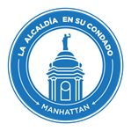
LA CIUDAD DE NUEVA YORK
OFICINA DEL ALCALDE

PARA DIFUSIÓN INMEDIATA
CONTACTO: pressoffice@cityhall.nyc.gov, (212) 788-2958

ALCALDE DE BLASIO ANUNCIA QUE EL DISEÑO FINAL DEL PROYECTO PARA DARLE CONTINUIDAD AL PASEO MANHATTAN GREENWAY WATERFRONT EN LA RIBERA ESTE COMENZARÁ LA PRÓXIMA SEMANA
La iniciativa de $100 millones es una medida de la administración a fin de impulsar el proceso para completar el paseo peatonal y ciclovía de 32 millas alrededor de Manhattan

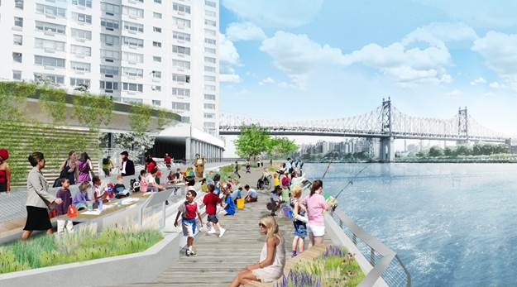

NUEVA YORK—Como parte de la semana la Alcaldía en su Condado, en Manhattan, el alcalde Bill de Blasio anunció hoy que el proceso de diseño formal para una nueva sección del paseo peatonal y ciclovía Manhattan Greenway Waterfront, entre East 61st Street y East 53rd Street, comenzará oficialmente la próxima semana. El alcalde y funcionarios locales recorrieron una parte del paseo y analizaron los planes para su expansión. La construcción del nuevo tramo comenzará en 2019 y se espera terminar en 2022.

“Manhattan Greenway destaca como un espacio abierto que conecta a las comunidades entre sí y también a la extensa y hermosa costa de Nueva York. Lograr la continuidad de este paseo mejorará enormemente la calidad de vida de los neoyorquinos y las personas del East Side que han impulsado durante décadas este”, dijo el alcalde Bill de Blasio.

“Durante años los residentes del East Side han mirado el Hudson River Park preguntándose por qué no tenían ese mismo tipo de paseo de primer nivel a lo largo del East River,” dijo el presidente de la Corporación de Desarrollo Económico, James Patchett. “Hoy hemos dado un gran paso hacia esa realidad y cumplimos con la visión del alcalde de Blasio de tener un paseo peatonal y ciclovía totalmente conectada a Manhattan. Contar con este tipo de acceso es fundamental para la misión del EDC de crear barrios sólidos y construir una Ciudad aún más dinámica.”

“El Departamento de Parques espera impulsar el trabajo que estamos haciendo con EDC, CDOT y la comunidad para hacer realidad los esfuerzos de la Ciudad para conectar comunidades y crear paisajes panorámicos al diseñar una explanada continua a lo largo del East River”, señaló el comisionado de Parques de la Ciudad de Nueva York, Mitchell J. Silver, FAICP.

Para obtener más imágenes del proyecto, haga clic aquí.

En abril de este año, el alcalde destinó $100 millones en capital de la Ciudad para reducir significativamente el espacio más grande que queda sin construir, como parte de una medida de la administración para impulsar y completar el paseo peatonal y ciclovía de 32 millas alrededor de Manhattan. El anuncio del alcalde se suma al esfuerzo de largo aliento de funcionarios electos locales y defensores de la comunidad para financiar y construir una explanada continua.

El proyecto recibió la aprobación inicial de la Guardia Costera de Estados Unidos, el Cuerpo de Ingenieros del Ejército y el Departamento de Conservación Ambiental del Estado. La estructura se basará en planes previamente desarrollados en consulta con un consejo compuesto por representantes de la Alcaldía y funcionarios locales.

Organizaciones cívicas y funcionarios electos locales, entre ellos la presidenta del condado Gale Brewer, la congresista Carolyn Maloney, la senadora estatal Liz Krueger, los miembros de la asamblea Dan Quart y Brian Kavanagh, los miembros del concejo Ben Kallos y Dan Garodnick, han impulsado el proyecto de completar el paseo peatonal y ciclovía durante décadas, lo que ha dado como resultado un progreso continuo a lo largo de la ruta.

El presupuesto ejecutivo de la Ciudad también destinó $5 millones para un estudio de varias agencias que se completará este año sobre los tramos que quedan por completar del paseo Greenway Waterfront de Manhattan. El estudio identificará las soluciones necesarias para mejorar los puntos de congestión y completar los tramos que faltan, como base para el financiamiento adicional en la próxima actualización del plan de capital de la Ciudad.

Desde su creación en 1993 bajo el alcalde David Dinkins, cada administración ha contribuido al paseo peatonal y ciclovía Manhattan Waterfront Greenway. La última sección importante que se añadió fue un tramo de diez cuadras en Riverside Park entre West 81st Street y West 91st Street, lo que llevó a completar una avenida contigua al río Hudson de 11 millas, desde Battery hasta el puente George Washington. Con más de 7,000 ciclistas cada día, es la ruta más activa en bicicleta del país.

###

