
THE CITY OF NEW YORK
OFFICE OF THE MAYOR
NEW YORK, NY 10007

FOR IMMEDIATE RELEASE, October 6, 2017
CONTACT: pressoffice@cityhall.nyc.gov, (212) 788-2958

MAYOR DE BLASIO ANNOUNCES FULL FUNDING TO RESTORE SUNSET COVE

$7 Million for Crucial Ecological Restoration and Resiliency in Broad Channel
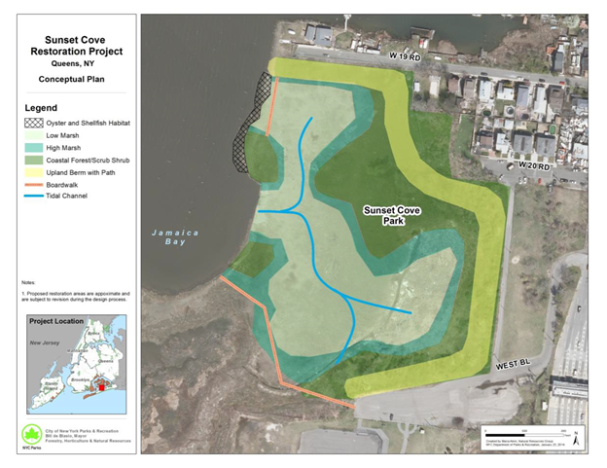

NEW YORK—Mayor Bill de Blasio today announced an allocation of $7 million for the restoration of Sunset Cove in Broad Channel, Queens. The $14 million project is an important ecological restoration that will help protect the community from floodwaters and improve the health of Jamaica Bay. The project will remove contaminated fill, provide access to the park, and create a resilient shorefront that restores native habitat for fish, birds and wildlife, and will restore critical tidal wetlands in Jamaica Bay. Deputy Mayor Alicia Glen, NYC Parks Commissioner Mitchell J. Silver, FAICP, and Chief Resiliency Officer Dan Zarilli joined residents and officials in Broad Channel to mark the announcement.

“We are hard at work building a more fair and resilient city,” said Mayor Bill de Blasio. “Not only will the residents of Broad Channel have better protection from storm surges, but they will also have a reinvigorated ecosystem and better access to their park. The City looks forward to working closely with our partners to get shovels in the ground next year.”

Work will include the restoration of five acres of salt marsh and seven acres of coastal woodland; removal of contaminated fill across the site and replacement with clean sand; and the installation of a pedestrian pathway along a perimeter berm which will provide both access and storm protection. The design for Sunset Cove was completed in May 2016. Following the design, the project received bids that were nearly double the available budget, effectively stalling progress. Thanks to the new allocation from Mayor de Blasio, the project will be able to move forward immediately. Construction is expected to begin in spring 2018 and completed in 2019.

As it focuses on both NYC Parks and National Park Service property, the restoration project will strengthen partnerships between City and Federal partners. In addition, the Jamaica Bay Ecowatchers will contribute to marsh-planning efforts with support from the American Littoral Society.

The mayoral funding matches an existing $7 million for the restoration of Sunset Cove from a Department of Interior – National Fish and Wildlife Foundation Grant and DEC Mitigation funding.

“NYC Parks’ public waterfront is our city’s first line of defense against climate change. Thanks to the new funding, and the tireless efforts of community groups like the Jamaica Bay Ecowatchers, we will strengthen this crucial piece of shoreline, and help protect Broad Channel from the effects of future floods and storm surges,” said Parks Commissioner Mitchell J. Silver, FAICP.

“In the time since Hurricane Sandy demonstrated our vulnerabilities to the growing risks of coastal storms, sea level rise, and climate change, New York City has continued to implement a comprehensive $20 billion resiliency program,” said Daniel Zarrilli, NYC’s Senior Director of Climate Policy & Programs and Chief Resilience Officer. “Part of that program involves expansion of coastal protection and enhancements to the ecology of Jamaica Bay, one of our greatest natural resources. Today’s announcement in Sunset Cove represents a critical step to completing both ecological restoration and coastal resiliency that the City and its partners are taking to make Broad Channel safer and more prepared for the growing risks of climate change.”

"The National Park Service is proud to partner with NYC on this project. NYC Parks has a proven track record of successful waterfront projects and community engagement," said Jen Nersesian, Superintendent, Gateway National Recreation Area. "We are pleased to see that City has leveraged the $5.8 million of Department of Interior funding to restore ecological function and public access to Sunset Cove."

“The restoration of Sunset Cove will certainly be a boon to the wildlife that make Jamaica Bay home, but it will also benefit the families of Broad Channel by protecting them against flooding along the shorefront and in the wetlands. These substantial investments are a reflection of New York’s commitment to think creatively and act boldly to address climate change and mitigate its impacts. Thanks to Mayor de Blasio’s allocation, full funding for Phase 1 is now secured, and work can now proceed on this critical restoration and resiliency project. This is great news for all who are care deeply about the long-term resilience of Jamaica Bay, for all who are passionate about environmental conservation, for all who are dedicated to the ecological education of our children,” said Queens Borough President Melinda Katz.

“I am pleased that the City is investing money for the restoration of Sunset Cove. Sunset Cove overlooks the shorefront and has great potential for both the residents and visitors of Broad Channel,” said Council Member Eric A. Ulrich. “This project will remove contaminated fill, provide much-needed access to the park, and restore the natural habitat for fish, birds and wildlife. It will be a great addition for our community once it is completed.”

"I am thankful that city funding will allow the Sunset Cove project in Broad Channel to proceed. Any opportunity taken to improve an area ravaged by Superstorm Sandy, in which the project has a direct benefit to the people and the environment, is a positive step forward,” said State Senator Joseph P. Addabbo Jr.

“Sunset Cove is such an incredible victory for this community, and I’m honored to have helped facilitate the process to where construction is set to begin next year. There’s a balance, a true relationship, between the people of Jamaica Bay and the Bay itself. This community resource will not only show off the natural beauty of our water and its ecosystem, but will create the next generation of environmentalists to preserve and protect it. Thanks to everyone who’s been working so hard to make the Cove a reality,” said Assembly Member Stacey Pheffer Amato.

###

