
THE CITY OF NEW YORK
OFFICE OF THE MAYOR
NEW YORK, NY 10007

FOR IMMEDIATE RELEASE: October 27, 2016
pressoffice@cityhall.nyc.gov, (212) 788-2958

DE BLASIO ADMINISTRATION, MONADNOCK DEVELOPMENT AND LOWER EAST SIDE PEOPLE’S MUTUAL HOUSING ASSOCIATION CELEBRATE THE OPENING OF NYC’S FIRST MICRO-APARTMENT BUILDING

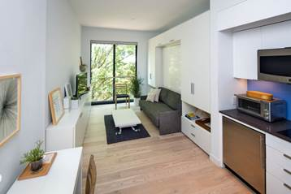

Carmel Place is now an affordable home to former homeless Veterans, low-income and middle-income New Yorkers

NEW YORK––The de Blasio Administration today joined Monadnock Development and the Lower East Side People’s Mutual Housing Association to celebrate the completion of Carmel Place, New York’s first micro-unit apartment building.

“Sometimes big ideas come in small packages. As New York continues to grow and change, we hear the call for innovative, more efficient homes that match the way New Yorkers live. Micro may not fit everyone, but it’s one of the affordable housing choices we need for a diverse and growing city. I welcome Carmel Place’s new residents to their gleaming new homes – and call on all innovators to keep it up,” said Mayor Bill de Blasio.

Kirk Goodrich, VP and Director of Real Estate Development for Monadnock Development, LLC said, “Carmel Place and micro studio apartments are about one thing – choice. New Yorkers want as many choices as renters in Hong Kong, Paris, London, Singapore, San Francisco, and other major cities around the world. By successfully re-introducing this apartment type, we have opened an important dialogue around diverse housing typologies that will help us address current and future housing challenges with an expanding array of housing options. This is a vision which Mayor de Blasio, City Planning and the housing agencies shared from day one and is the primary reason why Carmel Place exists.”

Purnima Kapur, Executive Director of the Department of City Planning, said, “For New York City to remain competitive, it must continue to provide a variety of housing choices at a range of affordability levels to serve our current residents and those who seek to come here. This project exemplifies our openness to exploring innovative approaches, including through zoning, to accommodate evolving housing needs of a diverse population.”

"The City and its development partners must be imaginative when seeking new ways to meet each of the city’s affordable housing needs. Carmel Place represents an inventive model that could help address the needs of New York’s growing small household population," said New York City Department of Housing Preservation and Development (HPD) Commissioner Vicki Been." I want to thank Monadnock and all of our development partners for their vision and creativity, and invite more thoughtful development plans as we work together to create more affordable housing opportunities for all New Yorkers."

"Carmel Place and micro-unit apartments in general are an idea whose time has come. We commend our City partners, Monadnock, and the entire Carmel Place development team on this innovative new model. With 15 percent of the units set aside for homeless veterans, this residence also assists the City in its goal of ending veteran homelessness, showcasing the power of public-private partnerships. The New York City Department of Veterans Services applauds this effort, and encourages all developers to build integrated housing that helps our most at-risk veterans,” said Department of Veterans’ Services Commissioner Loree Sutton, MD.

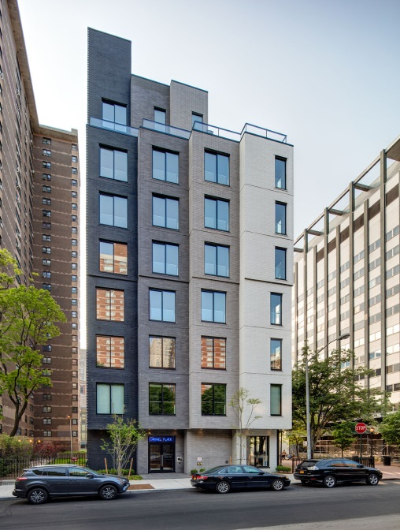
Carmel Place, at 335 East 27th Street in Kips Bay, is the result of a 2013, City-led competition to explore innovations to help accommodate the City’s growing population of one- and two-person households, which are about 63 percent of the City's renters. The development team and nARCHITECTS were chosen through a competitive Request for Proposals to design, construct and operate the micro-unit apartment building which is located on what was a City-owned site. Construction was financed in 2014.

Carmel Place includes 55 micro-unit apartments that were thoughtfully designed to optimize space and maximize a sense of openness. The apartments measure between 260 and 360 square feet and have 9’8” floor-to-ceiling heights and expansive 8’ high windows. They feature ample storage and open kitchens. The building’s amenities include a gym, club room, resident lounge and outdoor terrace. Other amenities include a virtual doorman, laundry facilities, storage room and bike room.

11 of the affordable apartments at Carmel Place are renting for $950 a month, three for $1,492 a month. The remaining eight homes are subsidized so that the lowest income households pay no more than 30 percent of their income in rent.

“The arrival of Carmel Place is historic. This pilot program is unique as an unattached stand-alone building comprised entirely of micro-unit apartments. I am very excited that this project will set aside 15 percent of the affordable units for United States Veterans who are in walking distance from the Veterans Hospital. I want to thank Tim Sullivan, former staff person to Deputy Mayor Steele, for working with me and Community Board 6 on securing a diversity of income bands on this project, as well as permanent affordable units for our Veterans. Lastly, I would like to thank Former Mayor Michael Bloomberg for his vision and leadership on this project. I believe this is a legacy we can all be proud of,” said Council Member Rosie Mendez.

State Senator Brad Hoylman said, "These apartments are small but the needs they will serve in our city are enormous. I'm especially glad that 40 percent of the units will be affordable to very-low income and middle-income households and that homeless veterans will be prioritized. I thank Deputy Mayor Glen and the de Blasio Administration for bringing this important housing experiment to fruition."

While the foundation, utilities and ground-floor were built using traditional construction methods, Carmel Place’s micro-unit apartments were built with prefabricated modules. The building meets all local, State and federal housing regulations, including accessibility guidelines for people with disabilities.

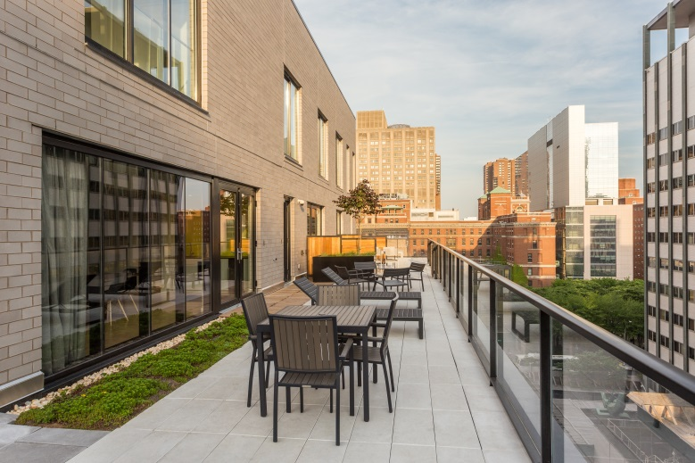
40 percent of the mixed-income rental building is affordable to very low-income households and middle-income households. Eight apartments serve formerly homeless veterans through the Veterans Affairs Supportive Housing program. The VASH apartments receive project-based Section 8 vouchers that ensure residents pay only 30 percent of their income towards rent. 11 apartments are affordable to households earning as little as $45,085 for an individual. Three apartments are affordable to households earning a minimum annual income of $76,835 for an individual.

The total development cost for Carmel Place is approximately $16.7 million. HPD provided $1.167 million in City Capital and allocated $1.06 million in Federal HOME Funds toward the development. The project is located on land that was formerly owned by the City, and which was conveyed at a nominal cost to subsidize the affordability of the project. The project also received a $10.3 million private bank loan from M&T Bank.

###

Photo credits to James Shanks and Cameron Blaylock

