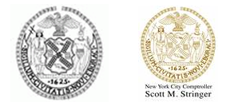

FOR IMMEDIATE RELEASE: September 28, 2016
CONTACT:
Mayor’s Office, pressoffice@cityhall.nyc.gov, (212) 788-2958
Tyrone Stevens, tsteven@comptroller.nyc.gov, (212) 669-4328

STATEMENT FROM MAYOR DE BLASIO AND COMPTROLLER STRINGER ON WELLS FARGO

“The scope of misconduct at Wells Fargo is simply shocking, damaging the bank’s finances and reputation. The Board’s clawback of compensation from senior executives is a start, but is far from enough. The Board must restore investor and public confidence by completing its independent investigation quickly and holding senior management accountable. If they fail to adequately address these issues, we will be forced to reexamine our business relationships and investments.”

###

