Mayor Adams Announces NYC Hits All-Time High in Total Jobs, Recovery of Nearly 1 Million Jobs Lost During Pandemic
October 19, 2023
Adams Administration Drives City’s Jobs Recovery More Than One Year Ahead of Projections
WATCH: Mayor Adams Celebrates Highest Number of Private-Sector Jobs in NYC History
NEW YORK – New York City Mayor Eric Adams today announced that New York City has set a record high for the total number of both public and private sector jobs in city history, with 4,709,400 total jobs, according to new data released by the New York State Department of Labor. With this milestone, the city has regained all of the 946,000 private sector jobs lost during the COVID-19 pandemic — surpassing the previous record of 4,702,800 total jobs set in January 2020 — and marked a new phase in its economic recovery.
Just 22 months into Mayor Adams’ tenure, the landmark moment in New York City’s recovery comes more than a year ahead of Independent Budget Office estimates and just 17 months after the administration released its “Rebuild, Renew, Reinvent: A Blueprint for New York City’s Economic Recovery.” New Yorkers interested in taking the next step in their career through a new job, training, or education can visit the city's Jobs Ready NYC website.
“In the earliest days of this administration, our team was laser-focused on two connected goals: making New York City safer and accelerating our economic recovery. Today, not only do we continue to be the safest big city in America with overall crime continuing to trend down, but we have also fully recovered from a pandemic that left many counting New York City out by setting an all-time record for total jobs in the five boroughs — an achievement once predicted to take until 2025 or later,” said Mayor Adams. “This was no accident. It was the result of smart investments in public safety, a dedication to our public spaces and streetscapes, policies to allow businesses to grow, a new approach to workforce and talent development, and an unwavering commitment to the working people of this city. But our work will never be complete until these employment opportunities are shared equitably by New Yorkers in every community. In the months ahead, we will be implementing even more policies to help our small businesses grow, attract major employers from around the world, and put more New Yorkers on the path to a family-sustaining career.”
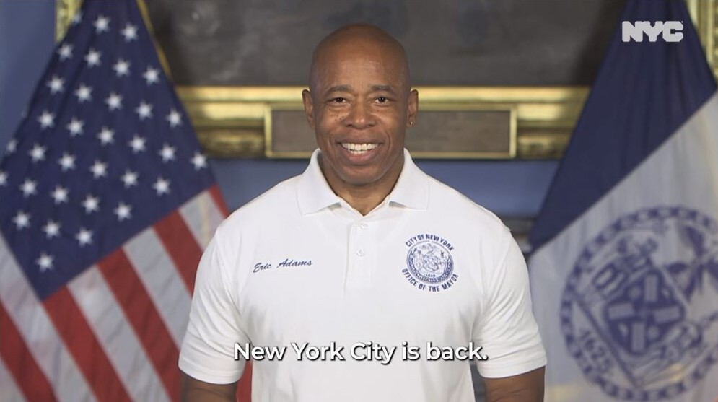
Mayor Adams celebrates the highest number of total jobs in New York City history. Credit: New York City Mayor's Office
“This is a watershed moment for the city,” said Deputy Mayor for Housing, Economic Development, and Workforce Maria Torres-Springer. “Mayor Adams’ economic agenda has powered an historic economic recovery, and we have now recovered the nearly 1 million private sector jobs that were lost during the COVID-19 pandemic. With this momentum, we will continue to focus tirelessly on the fundamentals and build an economy that lifts up New Yorkers across the five boroughs, as well as fortifies New York City’s position as the best place in the world to live, work, play, and study.”
“New York City’s resilience is on full display today as we surpass pre-pandemic total job levels, hitting an all-time high for the city,” said New York City Economic Development Corporation (NYCEDC) President and CEO Andrew Kimball. “Mayor Adams and this administration put forth a blueprint for economic recovery last year, and it is paying dividends. At NYCEDC, we will continue to work across the public and private sectors to foster an inclusive economic recovery that creates opportunities for all New Yorkers.”
“Today’s announcement is a testament to the resiliency of New Yorkers and the city,” said New York City Small Business Services (SBS) Commissioner Kevin D. Kim. “I’m proud of the role SBS had in reaching this milestone. Since Mayor Adams took office, our 18 Workforce 1 Career Centers connected more than 38,000 hardworking New Yorkers to good paying and stable jobs, strengthening our communities, and bringing us all one step closer to being the true ‘City of Yes.’”
“New York City is not only back, but also more committed than ever to an inclusive economy and shared prosperity,” said Mayor’s Office of Talent and Workforce Development Executive Director Abby Jo Sigal. “We know that we have incredible talent in every neighborhood of this city and this administration is committed to building and growing pathways to economic security and opportunity that connect low-income New Yorkers to the jobs of today and tomorrow.”
The city is currently conducting its monthly analysis of the New York State Department of Labor data and will be publishing a seasonally adjusted breakdown of private and public sector jobs for the month of August.
###

