
FOR IMMEDIATE RELEASE: January 27, 2025
CONTACT: pressoffice@cityhall.nyc.gov

MAYOR ADAMS ANNOUNCES CITY HALL, OTHER CITY BUILDINGS TO BE LIT YELLOW TONIGHT IN HONOR OF INTERNATIONAL HOLOCAUST REMEMBRANCE DAY

City Hall to Feature Exhibition Marking 80th Anniversary of Auschwitz Liberation with Survivor Artwork from Yad Vashem Collection

NEW YORK – New York City Mayor Eric Adams today announced that City Hall and other municipal buildings will be lit yellow tonight in honor of International Holocaust Remembrance Day. First designated by the United Nations General Assembly in 2005, International Holocaust Remembrance Day commemorates the liberation of Auschwitz-Birkenau in 1945. Additionally, to mark this significant 80th anniversary of the liberation of the Auschwitz concentration camp, City Hall will host a powerful exhibition titled “The Anguish of Liberation as Reflected in Art” in the City Hall Rotunda for the next week.

“On this 80th anniversary of the liberation of Auschwitz, we stand at a profound moment in history, where remembrance is not just about the past, but about securing our future,” said Mayor Adams. “As mayor of the city that proudly houses the largest Jewish community outside of Israel, I am deeply moved by the resilience of our Jewish family, while remaining ever mindful of the devastating void left by the Holocaust. In these challenging times, when antisemitism continues to surface in our society, New York City remains steadfast in our commitment to being not just a safe haven, but a beacon of hope for the Jewish community. The yellow lights illuminating our city buildings tonight serve as both a memorial to the 6 million lives lost and a bright reminder of our unwavering solidarity.”

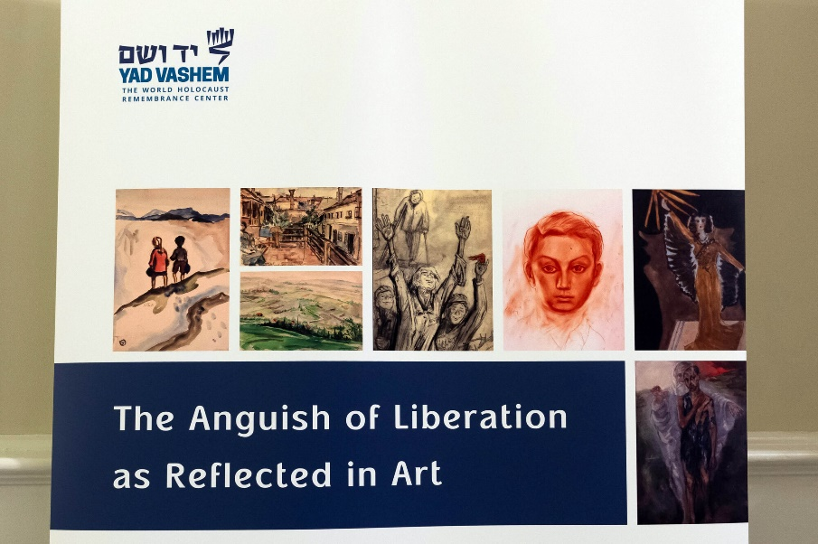

Anguish of Liberation,' Exhibit. City Hall. Credit: Ed Reed/Mayoral Photography Office.

“The Anguish of Liberation as Reflected in Art” — a special exhibition featuring works from the Yad Vashem Art Collection — showcases profound artistic expressions created by Holocaust survivors in the immediate aftermath of liberation. Through their artwork and personal stories, these survivors bear witness to humanity's darkest chapter. Their creative testimonies speak to the triumph of dignity over despair and stand as powerful reminders of our duty to preserve these memories.
In addition to City Hall, the following city buildings will be lit up yellow starting tonight at sundown:
- Bronx Borough Hall: 851 Grand Concourse, Bronx, NY 10451
- The David N. Dinkins Manhattan Municipal Building: 1 Centre Street, New York, NY 10007
- Queens Borough Hall: 120-55 Queens Boulevard, Jamaica, NY 11424
- Staten Island Borough Hall: 10 Richmond Terrace, Staten Island, NY 10301
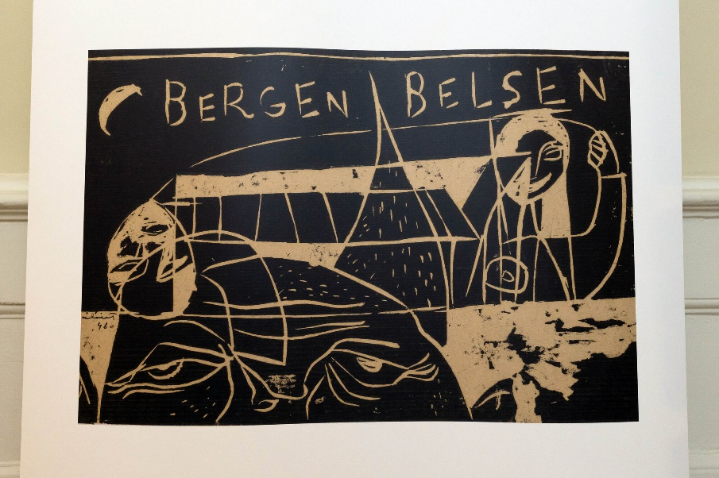
Anguish of Liberation,' Exhibit. City Hall. Credit: Ed Reed/Mayoral Photography Office.
“Today marks the 80th anniversary of the Liberation of Auschwitz, and the illumination of City Hall in yellow as part of the World Jewish Congress’ #WeRemember campaign, reminds New Yorkers of the atrocities of the past and the possibilities in the future,” said Ronald S. Lauder, president, World Jewish Congress. “The only way to combat hate is through education, and we must teach future generations that there is far more that unites us, than divides us. I would like to thank Mayor Adams for once again lighting up New York City yellow in honor of this important day.”
“Yad Vashem's poignant exhibition, ‘Anguish of Liberation,’ on display at City Hall, is far more than a collection of artwork — it is a profound testament to the atrocities of the Holocaust and the enduring strength of the human spirit. These works give a voice to the unspeakable torment of loss, the fragility of newfound freedom, and the resilience to rebuild shattered lives,” said Dani Dayan, chairman, Yad Vashem. “This exhibition compels us not only to reaffirm our shared responsibility and preserve these stories but to act, to remain vigilant against the erosion of basic human values as a result of the spread of contemporary antisemitism and hatred. Yad Vashem is extremely grateful to Mayor Eric Adams for supporting the display of this impactful exhibition.”

“As a grandson of Holocaust survivors and World War II veterans, Holocaust Remembrance and awareness are very personal to me. Remembrance and resilience are integral to our continued fight against antisemitism and hatred in all its forms,” said Mark Treyger, CEO, Jewish Community Relations Council of New York. “Seeing municipal buildings lit in yellow and showcasing the artwork of Jews liberated from Auschwitz in City Hall will remind New Yorkers that the city stands with our Jewish community at this pivotal moment in history. By honoring the memories of the 1 million Jews and thousands of others murdered at Auschwitz, the city reaffirms its commitment to ensuring that such atrocities are never repeated. The Jewish Community Relations Council of New York expresses its profound gratitude to Mayor Adams and his office for honoring Holocaust Remembrance Day in such a meaningful way.”

###

