From: Leibel, Daniel (DDC)
Sent: Thursday, July 28, 2016 4:51 PM
Cc: Williams, Shavone (DDC)
Subject: PRESS RELEASE: DDC and FDNY Break Ground on New Home for Rescue Company 2 in Brooklyn



FOR IMMEDIATE RELEASE

Shavone Williams Dan Leibel
williamsh@ddc.nyc.gov leibelda@ddc.nyc.gov
718-391-1583 718-391-1251

DDC and FDNY Break Ground on New Home for
Rescue Company 2 in Ocean Hill

New Firehouse to Lead in Energy Efficiency

(Brooklyn, NY – July 28, 2016) New York City Department of Design and Construction Commissioner Feniosky Peña-Mora and Fire Department Commissioner Daniel A. Nigro joined today to officially break ground on a new 21,000-square-foot firehouse for Brooklyn’s Rescue Company 2. The $32 million project will provide space for multiple FDNY vehicles, as well as ample space for tools, special rescue gear such as SCUBA equipment. An interior space from ground to roof level will be a training area for the Company’s firefighters.

“We are proud to break ground on a state-of-the-art new home for Brooklyn’s Rescue Company 2. This firehouse will be a leader in energy efficiency, moving our city closer to an environmentally sustainable and resilient future. With ample space for tools and a training facility on the roof, this firehouse will be the impressive space that New York’s bravest deserve,” said Mayor Bill de Blasio.

“DDC is pleased to break ground, in support of the Mayor’s vision for an environmentally sustainable and resilient City, on a new firehouse for Brooklyn’s Rescue Company 2,” said DDC Commissioner Feniosky Peña-Mora. “The building is designed to be a leader in energy efficiency and will provide ample space for the firefighters to train for whatever challenges face New York’s bravest. Ocean Hill will be able to take great pride in this building when it is finished.”

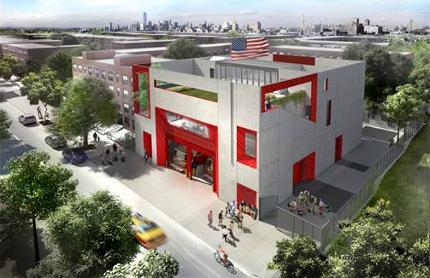
Rendering of the new firehouse for Rescue Company 2 in Crown Heights, Brooklyn

“Rescue Company 2 has a proud and storied history of bravery and service,” said FDNY Commissioner Nigro. “The construction of their new state-of-the-art home in Brooklyn will mean more opportunities for the highly-skilled members assigned there to train for the wide variety of life-threatening emergencies they respond to each and every day.”

Rescue Company 2, one of FDNY’s five rescue companies, is a specially-trained unit that responds to a variety of unique emergencies including fires, building collapses, high-angle rescues, hazardous materials incidents and water rescues. Their new facility will be organized around a large interior space that extends from the ground to roof level. This space will enable the company to practice rescue scenarios that mimic conditions common to the City, using its height and associated elements of balconies, bridge, doorways, ladders, and stairs.
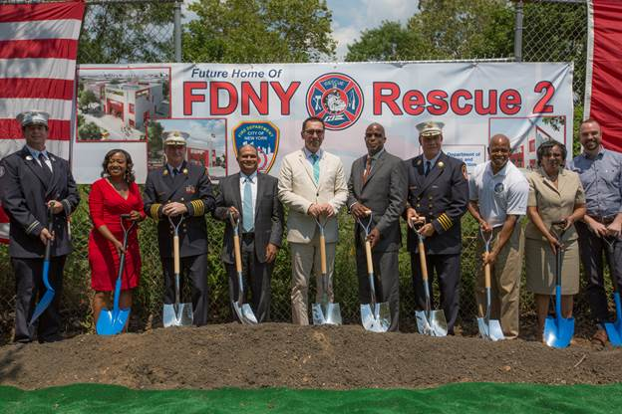
(Left to right) Rescue 2 Captain Liam Flaherty, Councilwoman Darlene Mealy, Chief of Department James E. Leonard, DDC Commissioner Feniosky Peña-Mora, FDNY Commissioner Daniel A. Nigro, First Deputy Commissioner Robert Turner II, FDNY Chief of Operations John Sudnik, Brooklyn Borough President Eric Adams, Brooklyn Community Board 16 District Manager Viola D. Greene-Walker, and Studio Gang Archtiects’ Design Principle Weston Walker break ground for Rescue Company 2’s new firehouse in Ocean Hill.

The building, at 1815 Sterling Place in Crown Heights, is designed to maximize energy efficiency, reduce carbon emissions, conserve water, and contribute to a healthy urban environment through integrating environmentally responsible practices. A geothermal system, designed to sit 500-feet underground, will draw heat energy from the earth to provide perimeter radiators and unit heaters with support for regulating the temperature inside the building. Along with a solar water heating system, this will reduce by one-third the energy required to heat and cool the building.

A green roof and permeable pavement will also be included in the station to further reduce carbon footprint and help reduce stormwater runoff. Local, recycled and durable materials will be considered for all aspects of construction to ensure optimized performance and minimal environmental impact. The LED lighting will be equipped with motion sensors to reduce electricity usage.

The building was designed through a partnership with DDC and Studio Gang Architects. The LiRo Group will manage construction of the project and ZHL Group is on board as the contractor. Construction is expected to be completed by summer 2018.

# # #

ABOUT THE NYC DEPARTMENT OF DESIGN AND CONSTRUCTION

The Department of Design and Construction is the City’s primary capital construction project manager. In supporting Mayor de Blasio’s lenses of growth, sustainability, resiliency, equity and healthy living, DDC provides communities with new or renovated public buildings such as such as firehouses, libraries, police precincts, new or upgraded roadways, sewers, water mains in all five boroughs. To manage this $15 billion portfolio, DDC partners with other City agencies, architects and consultants, whose experience bring efficient, innovative, and environmentally-conscious design and construction strategies to city projects. For more information, please visit nyc.gov/DDC

