
FOR IMMEDIATE RELEASE: December 19, 2023
CONTACT: pressoffice@cityhall.nyc.gov, (212) 788-2958

MAYOR ADAMS ANNOUNCES NEARLY $30 MILLION IN FEDERAL FUNDING FOR QUEENS BOULEVARD SAFETY IMPROVEMENTS

Federal ‘Safe Streets and Roads for All’ Grant Will Add Permanent Safety Improvements to Significantly Reduce Crashes and Injuries

Award Also Funds Expanded Analysis of Traffic Injuries with Health Data, Expanded Safety Technology Use in City Vehicles

City Has Been Allocated More Than $1 Billion in Federal Infrastructure Funding Under Adams Administration

NEW YORK – New York City Mayor Eric Adams today announced that the city has been awarded $29.75 million in federal funding through the “Safe Streets and Roads for All” program. The grant is a part of the more than $1 billion in funding secured by the city’s Federal Infrastructure Funding Task Force, chaired by Deputy Mayor for Operations Meera Joshi, under the Adams administration. The grant — supported by U.S. Senators Charles Schumer and Kirsten Gillibrand and U.S. Representatives Nydia Velázquez and Grace Meng — will support permanently redesigning a section of Queens Boulevard in Woodside, as well as enhanced analysis of traffic injuries with health data. It will also allow the city to dramatically expand its use of intelligent speed assistance (ISA) technology to 1,700 additional city fleet vehicles.

“Every New Yorker — drivers, cyclists, and pedestrians alike — deserves to feel safe on our streets, and this $30 million investment from the Biden-Harris administration will supplement the additional $1 billion in federal funding our administration has already received to keep New Yorkers safe on our roads,” said Mayor Adams. “These funds will bring much-needed safety infrastructure to Queens Boulevard, help us understand how e-bikes have changed our streetscape, and expand efforts to make our city fleet as safe as possible. Public safety is the prerequisite to prosperity, and that is why our administration has fought for real investments in our city’s traffic safety.”

“Deep and lifesaving thanks to the Biden-Harris administration, Secretary Buttigieg, and our entire congressional delegation for recognizing New York City’s interdisciplinary approach to road safety, because every city agency plays a role in ending traffic violence" said Deputy Mayor Joshi. "This investment will allow us to build protected bike lanes and hardened infrastructure in Queens, to gather and analyze critical injury data focused on e-bikes, and to install speed limiters in our city fleet — and in totality will prevent traffic fatalities across the city.”

“The transformation of Queens Boulevard shows how street redesigns can prevent crashes, injuries, and deaths,” said New York City Department of Transportation (DOT) Commissioner Ydanis Rodriguez. “No street should be known as the ‘Boulevard of Death,’ and this grant funding will help us make permanent safety enhancements on Queens Boulevard. We thank the Biden-Harris administration and the entire congressional delegation for their support of Vision Zero and our efforts to reduce traffic fatalities across the city.”

“Street design is public health, and our choices can be lifesaving,” said New York City Department of Health and Mental Hygiene (DOHMH) Commissioner Dr. Ashwin Vasan. “We’re excited to be working with our Vision Zero partners, including the DOT and the Department of Citywide Administrative Services, to bring the winning combination of design and data to Queens Boulevard. Too many of our family, friends, and neighbors, across our city, have been impacted by traffic violence — this work has the power to ensure no one has to suffer this kind of tragedy again.”

“ISA is transforming how we safely operate our fleet, and with this investment we are solidifying it as an integral safety tool,” said New York City Department of Citywide Administrative Services Commissioner Dawn M. Pinnock. “Thanks to this federal funding, we'll be able to expand ISA's footprint to 2,000 additional city vehicles. This strengthens our position as a standard bearer for safety and better protects pedestrians, cyclists, and other motorists.”

The federal grant builds on the Adams administration’s efforts to make streets safer for all New Yorkers and road users, in the face of nationally rising traffic fatalities. Earlier this month, Mayor Adams launched an aggressive, three-pronged effort to rapidly accelerate those efforts, beginning by doubling down on the administration’s focus on improving safety at intersections. Under this initiative, the Adams administration will make safety improvements to intersections at double its current rate, the New York City Police Department will add traffic violence to its regular CompStat reporting, and the administration will make significant safety upgrades to city vehicles and vehicles of city contractors and licensees to make more vehicles safer across the five boroughs.

Queens Boulevard Redesign

The federal grant award includes $23.75 million to redesign Queens Boulevard from Roosevelt Avenue to 73rd Street. Until DOT began redesigning Queens Boulevard in 2015, it was one of the most dangerous thoroughfares in the entire city. Between 2009 and 2014, 42 people died or suffered serious injuries on this stretch of Queens Boulevard — once known as the “Boulevard of Death.” To save lives as quickly as possible, DOT used in-house resources to install a range of proven, interim safety treatments along the corridor. Those initial treatments reduced total crashes by 13 percent, pedestrian injuries by 42 percent, cyclist injuries by 12 percent, and total injuries by 4 percent.

The project is Phase A of a broader plan to upgrade the existing painted safety treatments along the Queens Boulevard corridor with concrete, solidifying the temporary improvements delivered in recent years. Construction is expected to begin in fall of 2024 and take three years. The improvements will include:
- Expanding and reconstructing the service road medians by providing a continuous, raised pedestrian mall and grade-separated bicycle path for the first time.
- Reconfiguring several slip ramps to improve safety for all road users, reduce crossing distances, and create calmer, more predictable driving behavior.
- Improving accessibility at all bus stops.
- Installing a planted buffer and vertical barrier to protect pedestrians from the traffic on the mainline of Queens Boulevard.
- Adding new lighting, public seating, and landscaping.

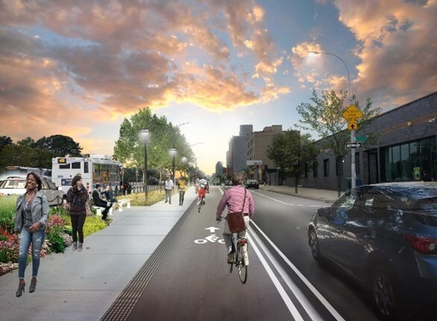

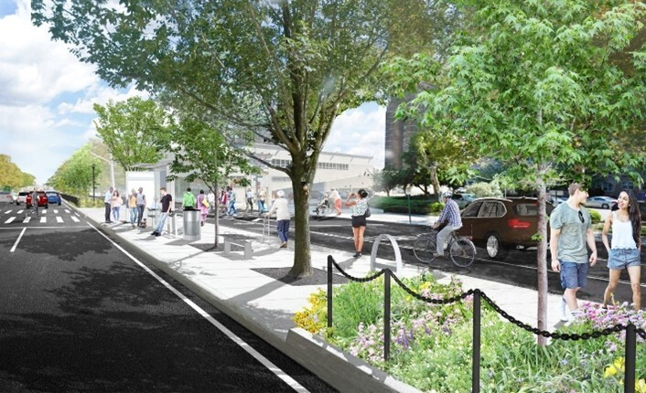

Renderings of safety upgrades to come to Queens Boulevard, from Roosevelt Avenue to 73rd Street, through the federal "Safe Streets and Roads for All" grant award. Credit: New York City Department of Transportation

Enhanced Injury Data Collection

The grant award also includes $3.6 million for DOHMH to expand health data collection on serious crash injuries of micromobility users. These projects will use mortality and hospital data to more fully describe the person injured and the injury as more and more New Yorkers embrace e-bikes and e-scooters. This data will better inform the city’s policymaking and efforts to redesign streets to reduce deaths and serious injuries among micromobility users.

Intelligent Speed Assistance Expansion

Lastly, the grant award includes $2.4 million to expand New York City’s use of active ISA technology to an additional 1,700 fleet vehicles. In August 2022, Mayor Adams and DCAS Commissioner Pinnock launched a pilot program to add active ISA technology in 50 city vehicles, restricting maximum speeds and ensuring almost universal compliance with speed limits across 750,000 miles traveled. Paired with additional technological improvements, the implementation of this tool has led to a 20 percent decrease in crashes involving city vehicles.

This is the second consecutive year in which the city has been awarded ‘Safe Streets and Roads for All’ funding. Last year, the city secured $21 million in federal funds to advance traffic safety, with $18 million of those dollars going to rebuild Delancey Street in Manhattan.

“This substantial federal investment from the Bipartisan Infrastructure Investment and Jobs Act will help New York City implement multiple lifesaving and traffic efficiency measures on Queens Boulevard. From elevated crosswalks, pedestrian malls and refuge islands, to enhanced medians and elevated, protected bike lanes, Mayor Adams is prioritizing improvements to increase the safety of pedestrians, cyclists and motorists alike,” said U.S. Senator Charles Schumer. “These federal funds empower New York City to strengthen roadway safety by implementing proven measures that will reduce injuries and traffic related incidents and improve efficiency. I’m proud to deliver this federal grant that will help improve the safety of this central roadway, and help save lives by driving forward much needed safety features, stopping accidents before they happen, and laying the foundation for safer and more efficient streets.”

“Queens Boulevard is one of New York City’s most dangerous roads, where dozens of pedestrians have died over the past few decades,” said U.S. Senator Kirsten Gillibrand. “I am so proud to bring home nearly $30 million in federal funding to reimagine the corridor, significantly reduce accidents and injuries, and make Queens Boulevard safe for our families to use.”

“I’m glad to have worked to secure these millions of dollars to make Queens Boulevard safer in my congressional district,” said U.S. Representative Grace Meng. “Queens Boulevard is a major artery in our borough, but we’ve seen over the years that it has also been a dangerous throughfare with many accidents causing deaths and serious injuries. This crucial federal money will ensure that more is being done to protect those who use Queens Boulevard, and it will go a long way toward saving lives. I’m thrilled that Queens continues to benefit from the Bipartisan Infrastructure Law that I helped pass in Congress. As New York’s representative on the House of Representatives’ Regional Leadership Council — which works to promote and implement legislation signed by President Biden — I will keep up the fight for our city and state.”

“For years, Queens Boulevard has seen far too many crashes and tragedies involving traffic, cyclists, and pedestrians,” said U.S. Representative Nydia M. Velázquez. “I was proud to champion the proposed redesign of Queens Boulevard along with other elected leaders and I’m thrilled that our efforts have secured nearly $30 million in federal funding to support this project, increase analysis of traffic injuries, and make city vehicles safer. The permanent redesign will reimagine the corridor and help ensure the safety of all New Yorkers traveling along this vital thoroughfare.”

“We are thrilled to hear about the $29.75 million federal grant awarded for vital safety improvements on Queens Boulevard, a main road to our city,” said New York State Assemblymember Steven Raga. “This funding signifies a strong commitment to reducing traffic-related injuries and fatalities, representing a significant step towards creating a safer, more accessible Queens Boulevard for all. I applaud our federal representatives and city officials for securing this grant and am eager to see the positive impact it will have on our community.”

“With the former Boulevard of Death already enjoying a rebirth in terms of traffic safety, this nearly $30 million grant will undoubtedly further our mission of making Queens Boulevard as safe as possible for all who use it, regardless of how they get around,” said Queens Borough President Donovan Richards Jr. “Our streets must be safe for all — drivers, bus riders, cyclists and pedestrians alike — and we can make them so if we continue to receive the financial resources we need to make the necessary improvements. Thank you to our partners in government for their critical work in securing this grant.”

“Queens Boulevard has long been referred to as Boulevard of Death due to high rates of traffic violence. Just this Halloween, a teenager was hit by a car while walking on the sidewalk. I am grateful for this much needed federal funding to proactively redesign Queens Boulevard to prevent any more deaths and injuries,” said New York City Councilmember Julie Won. “Queens Boulevard has the potential to be an efficient, safe, pedestrian friendly corridor and I look forward to a boulevard emblematic of the beautiful lives in Queens, not death.”

“It’s so important that government funding focuses on correcting the harmful car-centric design of past generations,” said Sarah Lind, co-executive director, Open Plans. “We know these street improvements work because they’ve already been used to reduce traffic violence along other sections of Queens Boulevard. Combining this good design with technology to limit dangerous speeds is a smart, multifaceted approach. By reforming old modes and employing new ones, we help create a brighter future where innovation and care intersect in a safer, more livable city.”

###

